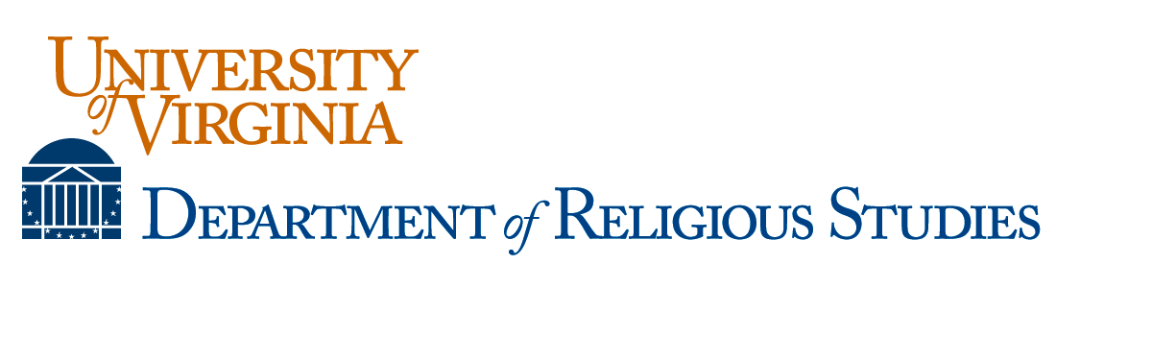
YEARLY PROGRESS REPORT FORM (Due at the end of each academic year)
Please submit a progress report to the Graduate Program Coordinator, copying your advisor, at the end of each academic year, including years when you are on dissertation completion status. Please consult with your advisor as you complete it (in person, when possible).

Date: Year in Program:
Student’s Name:
Research Area:
Advisor’s Name:
Dissertation Title (if applicable):
MA Thesis Title (if applicable):
Academic Progress (describe your academic progress over the academic year):

Academic Goals (describe your academic goals for the summer and next academic year):

Questions for PhD Students
What is your dissertation topic, or what topic(s) are you considering?

What do you need to learn over the next 12 months in order to prepare yourself to write or complete that dissertation?

What progress have you made towards your language requirements?

When will/did you complete your comprehensive exams?

If you are writing your dissertation, how many chapters did you complete this year and what is your timeline for the remaining chapters?

How many years of GSAS funding remain to you?
How many semesters have you served as a teaching assistant?
Do you expect to have an external fellowship next year?

Questions for Graduating MA Students
What will you be doing next? How well did the MA Program prepare you for the next step in your intellectual and/or professional development?

